MEDIA RELEASE
20 April 2019

Melanesian Media Group appointed Host Broadcaster for Samoa 2019 Pacific Games

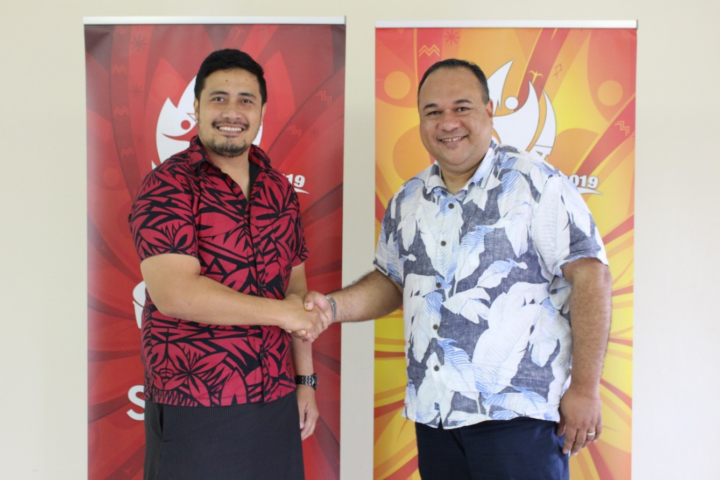
Pacific Games Office CEO Falefata Hele Ei Matatia and Richard Broadbridge at MMG’s contract signing in Apia.
(PACIFIC GAMES OFFICE); The Pacific Games Office is excited to announce the appointment of Singapore based Melanesia Media Group (MMG) as the Host Broadcaster for Samoa 2019 XVI Pacific Games in July.

The appointment of MMG as Host Broadcaster comes after the phase one scoping assignment contract undertaken by the Pacific Broadcasting Consultancy Company that ended in March.

As Host Broadcaster MMG will be responsible for the sale of rights and broadcast coverage of the Samoa 2019 Pacific Games, while the Pacific Games Office will retain all rights. The Broadcast of this year’s Games promises both LIVE and highlights coverage across the Pacific Islands, including Australia and New Zealand.
"MMG was awarded the contract based on its demonstrated track record in performing Host Broadcast duties for previous Games and Festivals.” said Falefata, CEO of the Pacific Games Office.

“Broadcasting the Games is no small task and will require support from across the region. MMG has prior experience in negotiating rights and is a regional specialist to have the Games covered well, even with the short amount of time available.”
MMG’s role will primarily be to secure a free to air play of all coverage in the Pacific Region. They will also find slots of highlights coverage and provide a platform for online, as well as secure production equipment and staff to ensure the Games is broadcasted to as many people as possible.

- - - - -Ends- - - - -

For more information contact: media@samoa2019.ws

