OFFICE OF THE PACIFIC GAMES 2019
Faleata Sports Complex
Tuanaimato
Email: info@samoa2019.ws

21 December 2018
Media Release

Electric Power Corporation offers support for Pacific Games 2019

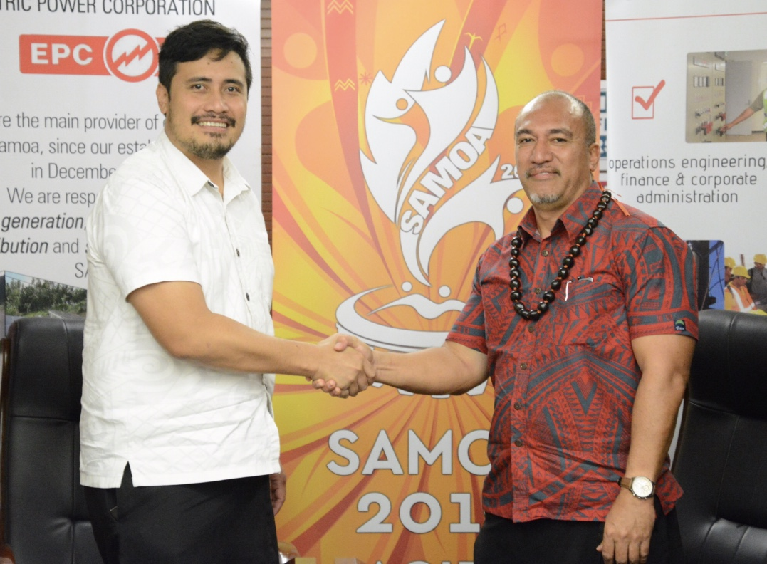
CEO of the Pacific Games Office Falefata Hele Matatia shaking hands with CEO of the Electric Power Corporation Tologata Tile Tuimalealiifano after the MOU signing this morning.”

(PACIFIC GAMES OFFICE); The Pacific Games Office is delighted to announce the Electric Power Corporation’s (EPC) support for the upcoming Pacific Games.

The announcement was made by the CEO of the Pacific Games Office (PGO), Falefata Hele Matatia and CEO of the Electric Power Corporation, Tologata Tile Tuimalealiifano during the signing of a Memorandum of Understanding agreeing to be a ‘Friends of the Games Sponsor’ for the Pacific Games 2019.

Falefata Hele Matatia in his words of acknowledgement said, “Samoa is making history through organizing the Pacific Games in less than two years and we need all the support we can garner from organizations such as EPC, therefore, we are very grateful for your positive response to join our family of partners and sponsors for the upcoming XVI Pacific Games next year.”

Following the signing, Tologata reiterated EPCs support for the games, “On behalf of the chairman, board members and management of EPC, I would like to firstly congratulate you and your office for taking on this huge challenge because I know it is not an easy task. We are excited to be of some help to the development and progress of the Games, and it will not end here. I understand that there are new buildings and renovations being done and we are more than happy to lend a hand wherever we can.”

The prospective sponsorship package is valued at ST$480,000 and highlights EPC as the first government entity to lend their support towards the games.

----------Ends-----------

For more information contact:
media@samoa2019.ws / +685 23843 or 7633848

