MEDIA RELEASE
3 May 2019

Ott Family supports Samoa 2019 Pacific Games

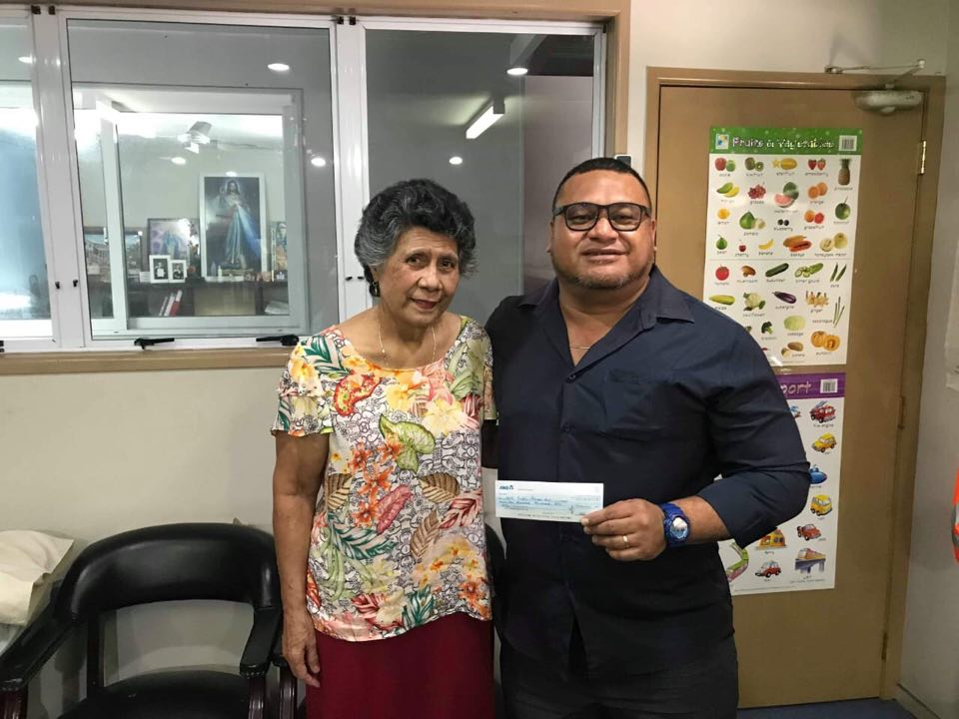
Beatrice Ott presents the Ott family donation to Tagaloa Su’a Faafouina Su’a.

(PACIFIC GAMES OFFICE); The Pacific Games Office is delighted to announce that the Ott Family has confirmed their support for Samoa 2019 Pacific Games.

The announcement was made by Tagaloa Su’a Faafouina Su’a, Director of Sponsorship for the Pacific Games.

“We are extremely grateful to the Ott family for their generous donation. $100,000 is not a small amount of money and will assist greatly in our preparations as we draw closer to the Games,” said Tagaloa.

“We, at the Pacific Games continue to be overwhelmed with gratitude for the outpouring support from our local businesses. The financial support towards the Games will help ensure that we host the best ever Games for our Pacific Island brothers and sisters.”

The Ott family’s donation is $100,000 and continues to mark the success of an extensive sponsorship strategy set up by the Pacific Games Office for the Pacific Region’s largest quadrennial games.

The Pacific Games Office continues to be the key focal point for all matters relating to Samoa 2019 Pacific Games.

In 65 days, Samoa will host 16th Pacific Games for the third time with 2007 being the most recent and 1983 being the first.

- - - - -Ends- - - - -

For more information visit www.samoa2019.ws

For further comments or to arrange an interview, contact: media@samoa2019.ws

