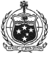
OFFICE OF THE PACIFIC GAMES 2019
Faleata Sports Complex
Tuanaimato
Email: info@samoa2019.ws

1 March 2019

Media Release

Pacific Games Chefs de Mission gathering concludes in Samoa

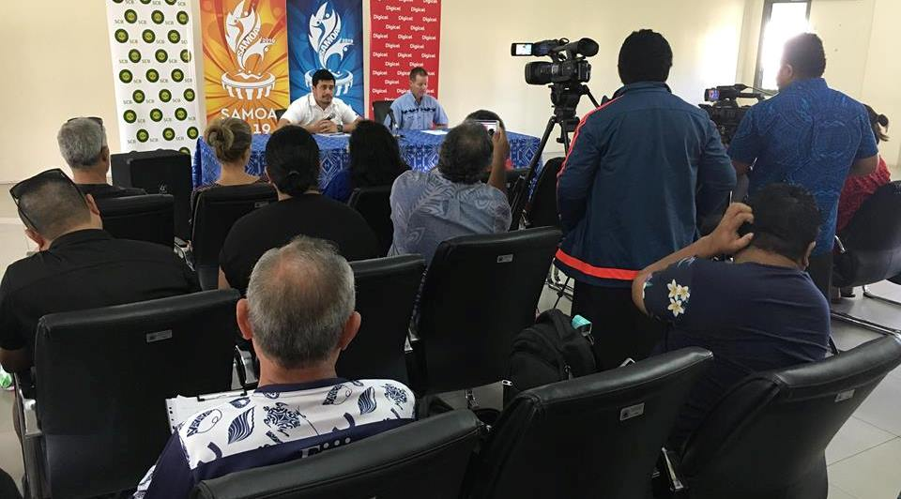
CEO of the Pacific Games Office, Falefata Hele Ei Matatia and CEO of the Pacific Games Council, Andrew Minogue at the Press Conference earlier today

(PACIFIC GAMES OFFICE); This week, the Pacific Games Office hosted 13 Chefs de Mission (CDM) from across the Pacific and Samoa, for a three-day seminar featuring presentations and venue tours by the Games Organizing Committee.

Held from the 27th of February through to the 1st of March, the seminar provided information on key areas such as Sports Services, Games Village Operations, Games Operations, Security, Catering and Accreditation.

The key objective of the seminar was to provide information to all CDMs efficiently to assist in their preparations for the upcoming Games.

“The Chef de Mission plays a vital role for each of the participating Pacific Games Authorities,” said Falefata Hele Ei Matatia, CEO of the Pacific Games Office.

“The usual practice is for CDMs to make a visit to the Host Country a few months out from the Games to assist in their preparations. Rather than having each CDM visit individually, we thought it would be best to have everyone come to Samoa at the same time, so the office sent an invitation out to all the participating PGAs with over half taking up the invitation.”

Falefata explained that having a large group of CDMs come at one time allows the Organising Committee to communicate information and lead tours in one go, as opposed to 13 separate times. The idea was to do it all at once to allow the Committee to concentrate all resources on final preparations for the Games.

The seminar included a press conference where the Organising Committee and the Pacific Games Council were able to provide an update of the Games as well as provide an opportunity for the CDMs to share their thoughts with media, concerning the gathering this week and give an update on their team preparations for the Pacific Games.

At the press conference, Andrew Minogue, CEO of the Pacific Games Council said that the CDM meeting this week has in many ways been beneficial for the CDMs and the Samoa 2019 Organising Committee.

“For the Chef de Missions, the main benefit is they’ve seen the venues, they’ve met the Organising Committee, they know who to talk to on the various issues, so it’s going to make their job easier back home putting their team together understanding what’s facing them here in Samoa,” said Andrew Minogue.
“For the organising committee, I think hearing from the Chef de Missions and understanding what their issues are and what their needs are at Games time is going to be very helpful because there have been things that we might not have thought of, or might not have thought are as high a priority, so it helps the Organising Committee.”

Furthermore, he believes that the CDM gathering has been a meeting of ideas and setting expectations amongst the two groups, the Chefs and the Organisers, and that it helps both parties to do things more efficiently because there’s not much time left.

The three-day seminar concludes today with one-on-one engagements between the Pacific Games Office and individual CDMs to respond to the needs of each PGA.

With just 128 days left before the Games, the Pacific Games Office continues to provide updates of their preparations to ensure that Samoa and the Pacific Region are well informed of the developments in Samoa’s efforts to host the Samoa 2019 XVI Pacific Games this July.

