MEDIA RELEASE
4 June 2019

Salafai Metal Industries (SMI) supports the Samoa 2019 XVI Pacific Games

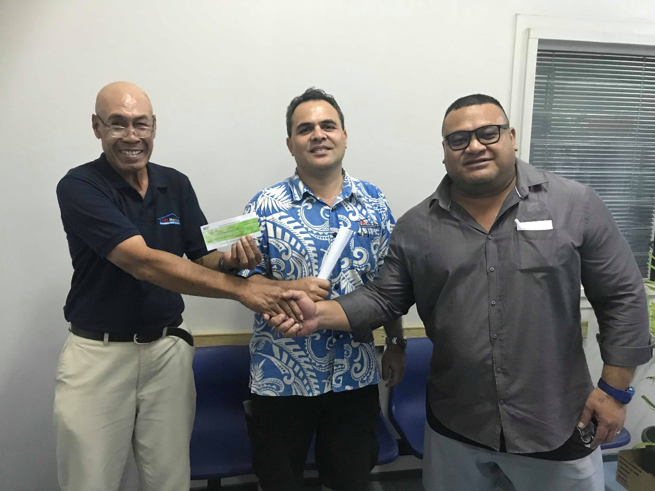
(L-R) Togafiti Leau Vaasa and Nigel Fepulea’i of Salafai Metal Industries (SMI) present Tagaloa Su’a Faafouina Su’a with their support for Samoa 2019.

(PACIFIC GAMES OFFICE); The Pacific Games Office is excited to announce Salafai Metal Industries (SMI) as a supporting sponsor of the Samoa 2019 XVI Pacific Games.

The announcement was made by the Director of Sponsorship, Tagaloa Su’a Faafouina Su’a.

“We have once again been blessed with the support of our people through this generous donation of $100,000 from SMI. With that being said, I would like to take this golden opportunity to thank Salafai Metal Industries for their kind support,” said Tagaloa.

“This support will assist us tremendously with our preparations for the upcoming Games and for that, we are truly grateful. May our good Lord replenish all that has been given to assist Samoa and its preparations for the Games in July.”

Salafai Metal Industries has served Samoa for many years as a one-stop shop for building materials. They initially went into business to provide roofing iron and metal products but recently diversified with ranges of products including furniture, auto and machinery.

The Pacific Games Office remains the key focal point for all matters relating to Samoa 2019 Pacific Games.

In 33 days, Samoa will host XVI Pacific Games for the third time with 2007 being the most recent and 1983 being the first.

- - - - -Ends- - - - -

For more information visit www.samoa2019.ws

For further comments or to arrange an interview, contact: media@samoa2019.ws

