MEDIA RELEASE
06 June 2019

Samoa releases design of $10 commemorative banknote for Samoa 2019 XVI Pacific Games

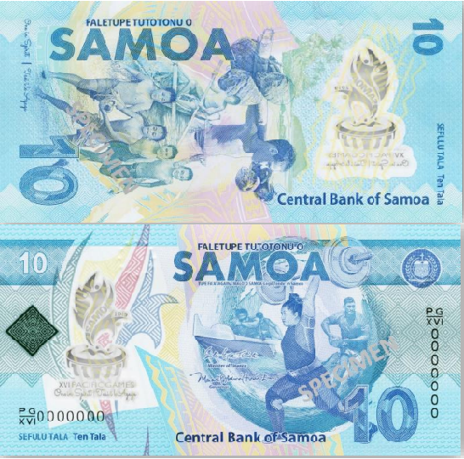
$10 commemorative banknote for Samoa 2019 XVI Pacific Games

(PACIFIC GAMES OFFICE); The Pacific Games Office is excited to announce the release of the limited edition 10 tala banknote by the Central Bank of Samoa, commemorating the Samoa 2019 XVI Pacific Games.

The new note design celebrates Samoa’s youth and sporting legacy. The images on the note depict their daily lives and the realisation of their sporting dreams.

The 10 tala is the second polymer banknote to be issued in Samoa, with the now-withdrawn 2 tala note being the first. The Samoa 2019 Pacific Games slogan “One in Spirit/Tasi i le Agaga” is illustrated on both sides of the note. The logo is uniquely depicted in a see-through window together with a tactile embossed feature to assist the visually impaired. Innovative security features have also been incorporated into the design to deter counterfeiting while making it easy to identify a genuine note.

The new note will enter circulation at the end of June 2019, and will circulate with the existing $10 tala which will remain legal tender.

- - - - -Ends- - - - -

For more information visit www.samoa2019.ws

For further comments or to arrange an interview, contact: media@samoa2019.ws

