New competition venue for the Sports of Va’a and Sailing at the Samoa 2019 Pacific Games
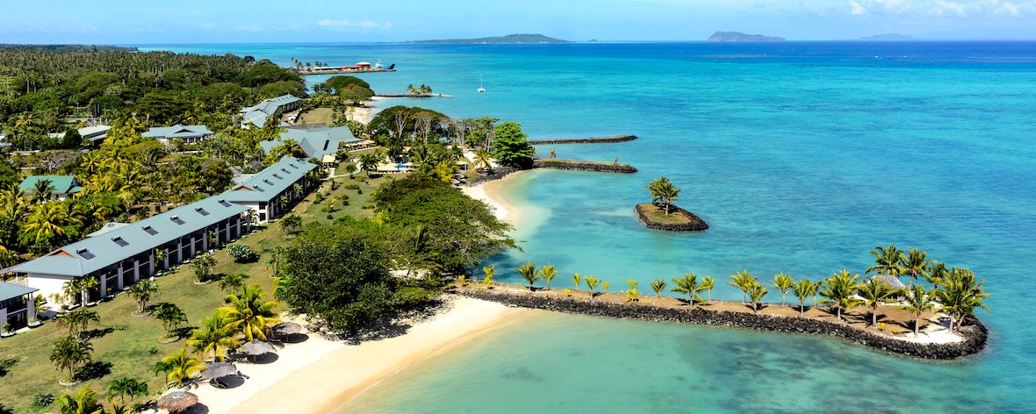
(PACIFIC GAMES OFFICE); The Pacific Games Office wishes to announce that there is a new competition venue for the sports of Va’a and Sailing at the Pacific Games this year. Originally planned for Mulinuu and Vaiusu, the competition venue will now be Mulifanua.
The change was made after several obstacles were encountered while planning for the use of Vaiusu Bay and Mulinu’u peninsula. The sport will keep the same schedule as set out in the sports program.
The Sports Committee in collaboration with the Samoa Outrigger Canoe Association believe that the use of Mulifinua as a competition venue is very ideal for Va’a as the bay provides flat water, with pristine conditions and great views of Samoa. The Samoa 2019 Pacific Games is excited to return Va’a and Sailing to Mulifinua, the home of the sport during the 2007 South Pacific Games, and expects to produce exciting competition while showcasing the beauty of Samoa.
