MEDIA RELEASE
17 June 2019

Official Handover of the Games Village for Samoa 2019 XVI Pacific Games

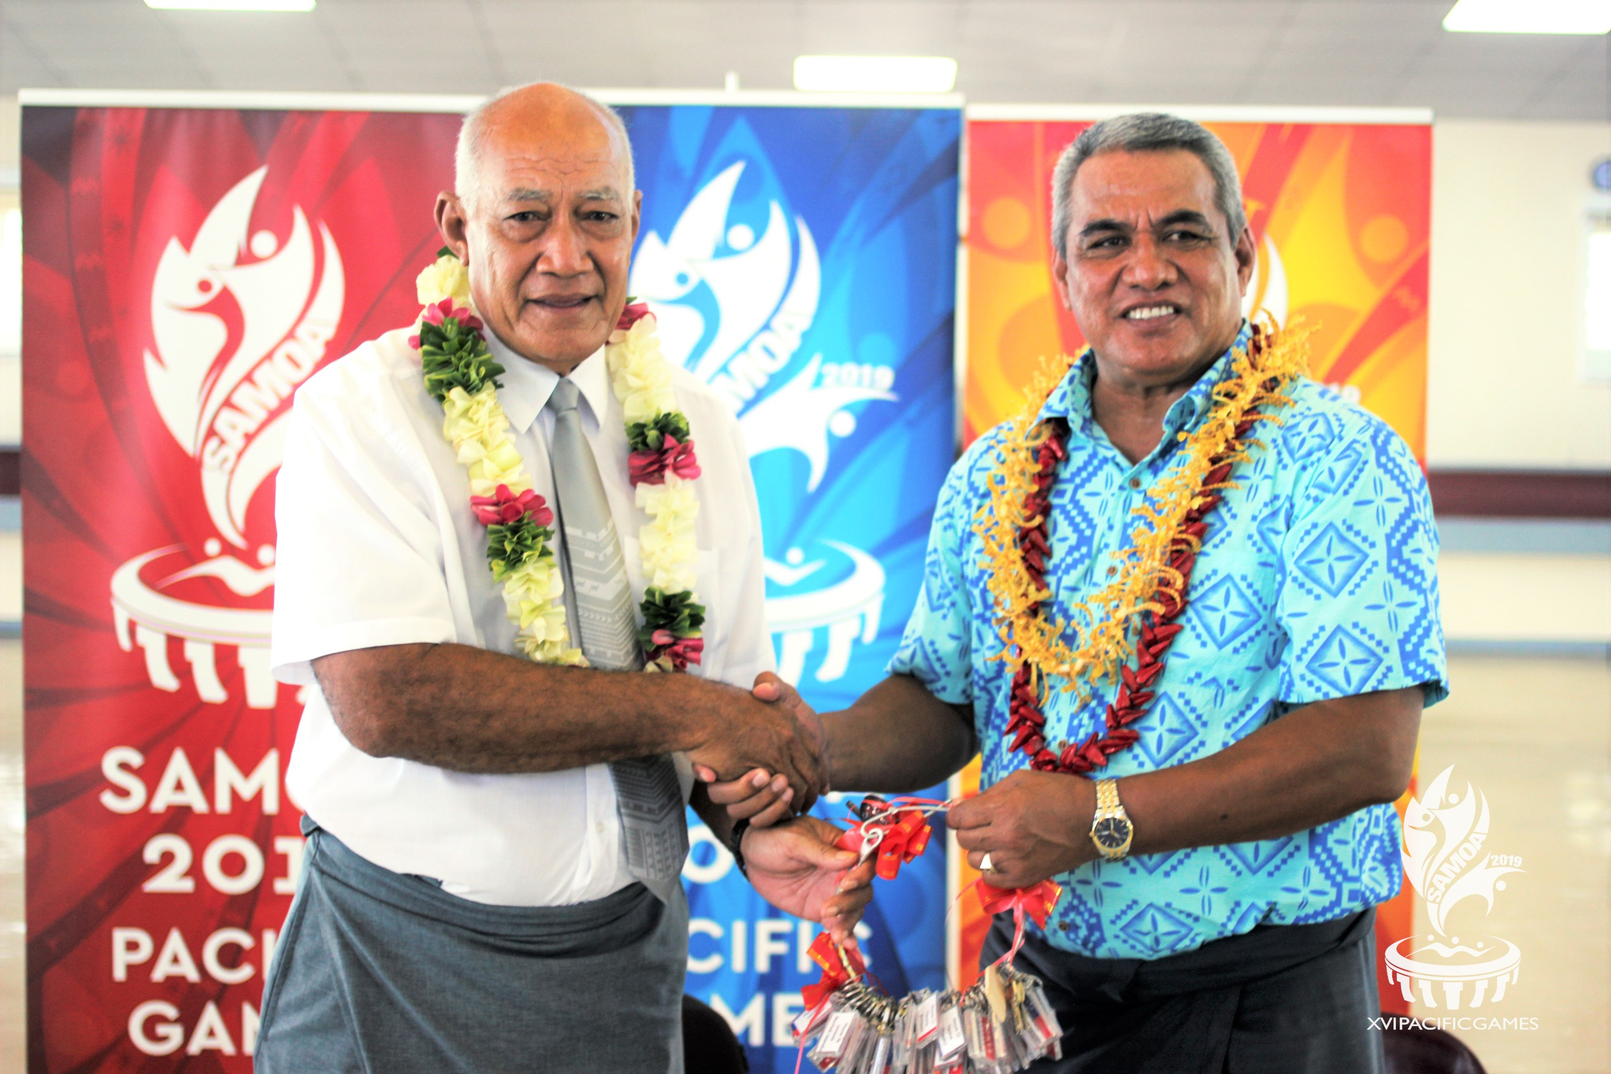
President of the Methodist Church of Samoa, Rev. Apineru Lafai hands over keys for the Methodist Church Compound to the Chairman of the Games Organising Committee, Loau Solamalemalo Keneti Sio.

(PACIFIC GAMES OFFICE); Today a ceremony was held to mark the handing over of the of the Faleula Methodist Compound by the Samoan Methodist Church to the Games Organising Committee in preparations for Samoa 2019.

Plans to utilise the Faleula Methodist Compound as the Games Village was unveiled in November 2018. More than 4,000 Athletes and Team Officials will be accommodated at Faleula over the course of the two week schedule.

Chairman of the Games Organising Committee, Loau Solamalemalo Keneti Sio was on site to officiate the handover.

“On behalf of the Government of Samoa and the Games Organising Committee, I would like to thank the President and the Methodist Church for availing the Faleula Methodist Compound for the XVI Pacific Games,” said Loau.

“Through this wonderful support from the Methodist Church, athletes and officials will get a chance to experience Samoan culture and our world famous hospitality.”

Teams will be accommodated using a combination of the 63 houses and four (4) school compounds - George Brown Pre-school and Primary School, Wesley College and Laumua o Punaoa Technical Centre - available. Each country will be allocated a house that can serve as a central hub for their delegation.

In addition to housing Athletes, the Games Village will also include spaces allocated for team management, medical and physiotherapy needs, Polyclinic, Police Headquarters, Dining Hall, Banking, Money Exchange, Digicel Network, Tourism Information, Merchandise, Sports Training, Laundry Services, and Transport.

Due to the size of the compound, there will be an internal shuttle for Athletes and Team Officials to access the various areas within the Games Village. This shuttle will run during the entire official games period.

The Games Village will be open from the 4 - 22 July, with a soft opening on the 3 July, 2019.

- - - - -Ends- - - - -

For more information visit www.samoa2019.ws

For further comments or to arrange an interview, contact: media@samoa2019.ws

