OFFICE OF THE PACIFIC GAMES 2019
Faleata Sports Complex
Tuanaimato
Email: info@samoa2019.ws

30 January 2019
Media Release

SPREP to co-lead with MNRE in Greening the Pacific Games

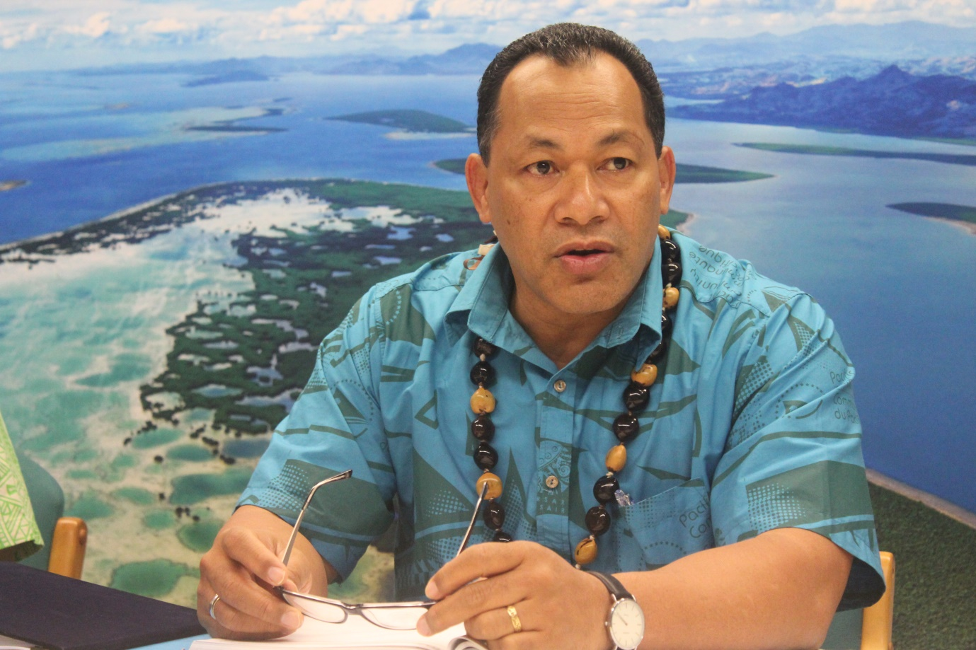
Director General of SPREP Leota Kosi Latu who will be co-leading the project with MNRE to Greenify the 2019 Pacific Games (PC: Government of Samoa)

(PACIFIC GAMES OFFICE); The Pacific Games Office is happy to announce that the Director General for the Secretariat of the Pacific Regional Environment Programme (SPREP) will co-lead with the Ministry of Natural Resources and Environment (MNRE) as co-Directors of Environment Sustainability for the upcoming Pacific Games.

“We are extremely excited to welcome the Director General of SPREP Leota Kosi Latu into the Organizing Committee for the Pacific Games. This is a very important project to the Government of Samoa as it aligns with its Environment Strategy to go plastic and straw free this year. The Games will be an excellent international platform that we can use to continuously address sustainability and waste management issues within the Pacific Region and hopefully outside of our region. We are very fortunate to have these two agencies partner up to help us continue to bolster the positive progress of the Pacific Games this year.” Said Loau Solamalemalo Keneti Sio, Chairman of the Pacific Games Organizing Committee.

The leading agencies have already identified human resources needed to carry out necessary work for the implementation of the work program for the project. MNRE and SPREP will also share personnel closer to the games to ensure that the Waste Management Strategy is properly carried out.

Key outcomes for the plan to Greenify the Pacific Games include:
- Introduction of green and reusable products as alternatives to single-use plastics
- Green facilities and waste management equipment made available to all sporting venues
- Portable Water Stations at desired locations
- Reusable water bottles and cups

Negotiations are underway with potential donors to come on board and help assist with Greening the Games.

