OFFICE OF THE PACIFIC GAMES 2019
Faleata Sports Complex
Tuanaimato
Email: info@samoa2019.ws

25 January 2019

Media Release

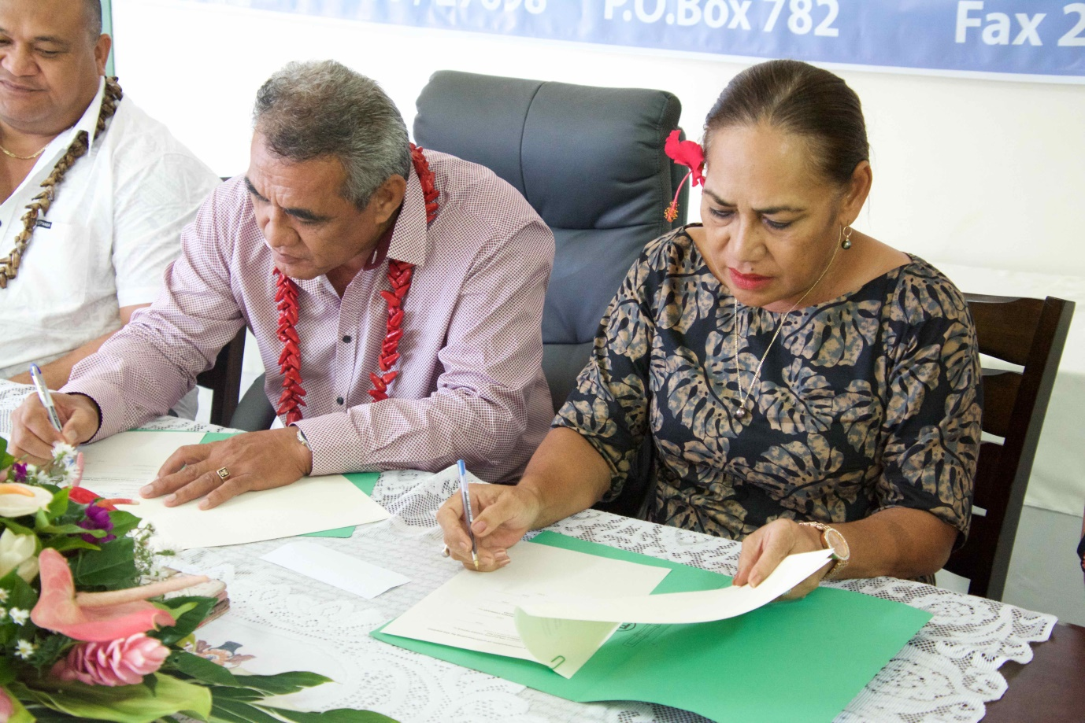
Chairman of the Pacific Games Committee and Minister of Education Sports & Culture, Loau Solamalemalo Keneti Sio together with Lutuiloa Vaiula Sialaoa-Solomona, CEO of Apia Insurance Company at the sponsorship signing this afternoon.

Apia Insurance Company joins as Silver Sponsor for Pacific Games 2019

(PACIFIC GAMES OFFICE); The Pacific Games Office is pleased to announce that Apia Insurance Company has joined the family of Sponsors as the Silver Sponsor supporting the Pacific Games next year.

Apia Insurance Company Limited has served the people of Samoa for more than a decade through providing fire and general insurance products for homes, businesses, vehicle, travel and property for more than 2,000 customers. It is a private and locally owned and managed company, with another branch in American Samoa as well as a sister company – Apia Finance offering small loans to customers and bridging finances to small businesses.

“On behalf of the Government of Samoa, Chairman and Directors for the Pacific Games, I would like to extend our heartfelt gratitude to Apia Insurance Company’s Management and staff for your kind donation. It is with great pleasure that I announce that Apia Insurance has so kindly joined us as a Silver Sponsor for the 2019 Pacific Games. I would like to acknowledge that their contribution continues to lift the progress of the Games preparations in a positive direction and we are extremely grateful for that,” said Loau Solamalemalo Keneti Sio, Minister of Education, Sports & Culture and Chairman of the Pacific Games Organizing Committee.

Chief Executive Officer of Apia Insurance Company (AIC), Lutuiloa Vaiula Sialaoa-Solomona spoke on behalf of the Chairman and Executive members of AIC’s Board of Directors before handing over the ST$200,000 cheque to the Chairman of the Pacific Games Committee.

“We are extremely delighted to be able to lend a helping hand to the Government of Samoa through the Honorable Minister, Loau Solamalemalo Keneti Sio and the Pacific Games Office as Samoa prepares herself to host the Pacific Island Nations for the Pacific Games this year. Apia Insurance Company is happy to be on board to support with the games because I know and understand that it is not an easy task. Wishing you the very best and may God bless all the preparations for the upcoming Games.”

The sponsorship deal is valued at $200,000 and continues to outline the success of an extensive sponsorship strategy set up by the Pacific Games Office for the Pacific Region’s largest quadrennial games.

The Pacific Games Office is the key focal point for all matters relating to Samoa 2019 and continues to work alongside the Organising Committee Directors to ensure a successful Pacific Games this year.

------- ENDS --------

For more information contact:
media@samoa2019.ws / +685 23843 or 7633848

